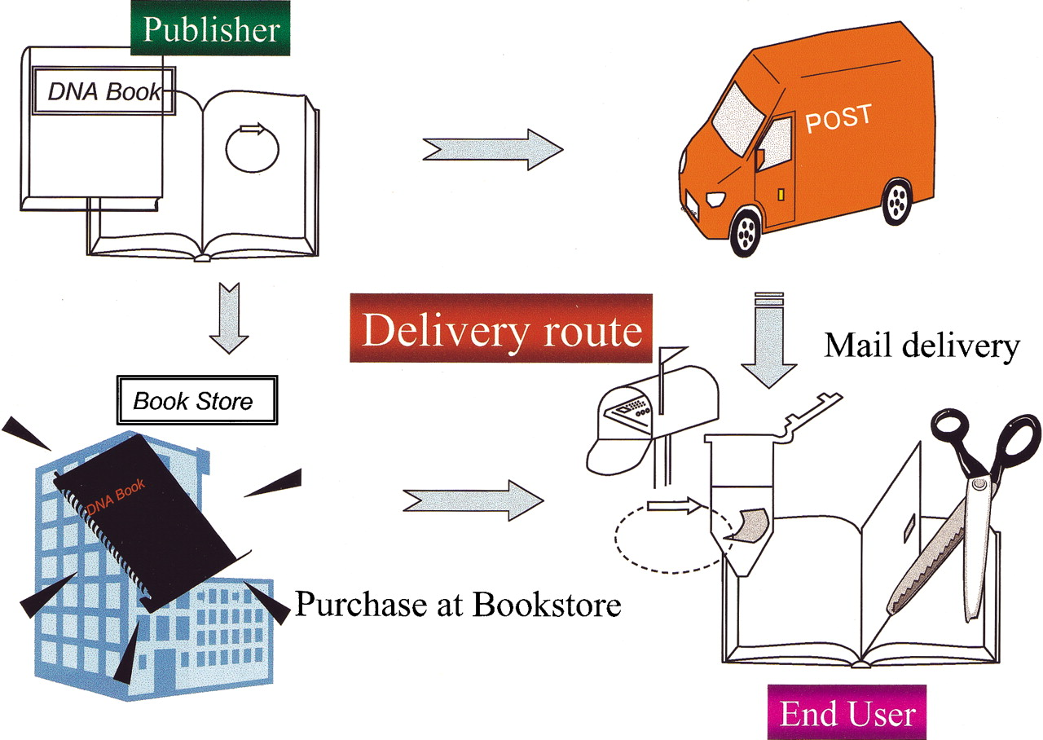

Concept of the “DNA Book.” DNA of genes are attached to pages of the DNA Book, and delivered to readers through conventional distribution channels, such as couriers and bookstores. Readers can extract and amplify DNA from the pages.

Figure from J.Kawai et al. (http://www.genome.org/cgi/doi/10.1101/gr.979503)